**1.7. Eco-Driving**

For the assignment, I used Carbon Monoxide (CO) as the parameter to decide on the best strategy. The python script to estimate the emission is attached.

As a continuation of example 1.2.6 of the textbook, we plot Emission vs Distance for different scenarios of β as shown in figure below.

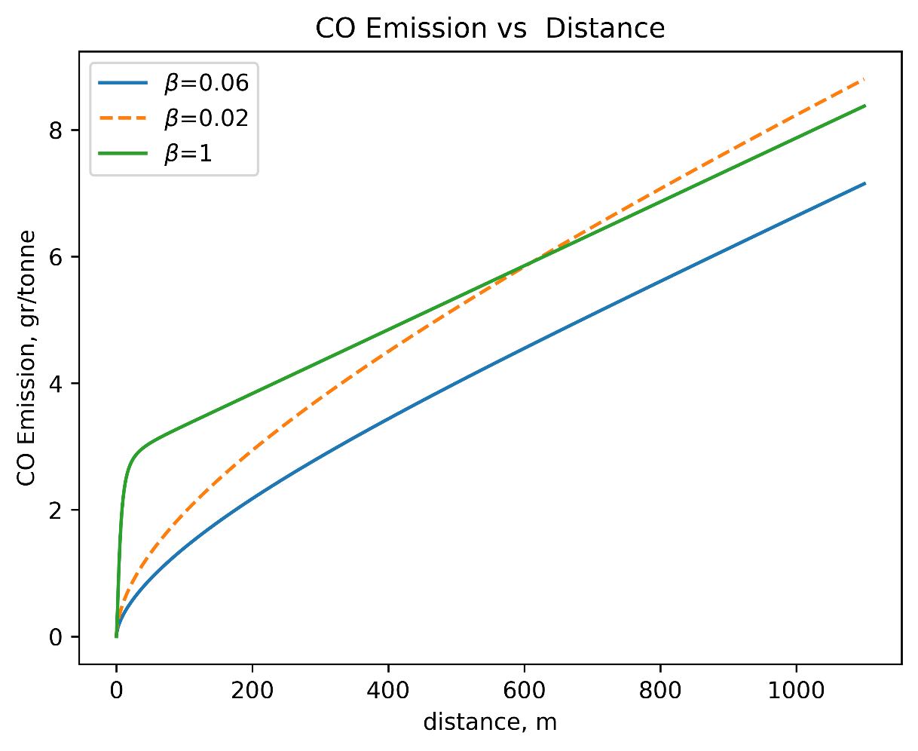

**Figure 1**: CO-Emission vs Distance based on approximate MOVES formula

Based on this, being an average driver (i.e. having β=0.06) is consistently the best strategy for minimize CO emissions. Going by the results for the others, within the limit of about 650m, being timid (β=0.02) is the second best strategy. However, beyond that, being an aggressive driver at β=1 is the second best strategy.